Sprint 3 Report

Plannertarium, by Team Scrumbags, 11/21/2023

# Actions to stop doing

The team should stop using the sprint plan to mark off completed tasks, and instead use the Jira scrum board; different members of the team marking off tasks in different places led to some confusion and consistency issues when making the sprint report. The team should also stop having members be late to meetings, since it leads to having to wait for members to show up or having to conduct the meeting without someone.

# Actions to start doing

The team should leave more feedback in reviews for pull requests, since it helps the developer understand where they can improve and what they have been doing well. We also need to ensure that the demo is a more accurate representation of the actual product, e.g with realistic event names rather than single-letter placeholders and such. We should also stop estimating tasks as taking 0 ideal hours, since that had a negative impact on our burnup chart’s progress.

# Actions to keep doing

# Our Sunday meetings are working well, since it helps us prepare and make any last minute changes before the demo during our TA meeting on Monday. Reviewing each other’s pull requests is also working well, since we can find oversights and errors in the code that the original author may have missed. Our frequent online communication is helpful in quickly fixing issues that arise, as well as making decisions about what to do next.

# Work Completed/Not completed

Completed tasks and stories are crossed out

1. ~~See my inputted information when I reopen the app so that I do not need to keep it open [13] - 3hrs~~
   1. ~~Handle Google SSO errors and integrate Google username into database - 2hr~~
   2. ~~Display a login screen for Android app - 1hr~~
2. ~~Manage my tasks in various time frames so I can get the amount of detail I need to plan my schedule [5] - 4hr~~
   1. ~~Create a new Widget on the UI to accept new tasks - 1hr~~
   2. ~~Display tasks in daily view - 2hr~~
   3. ~~Display tasks in weekly view – 0hr~~
   4. ~~Display tasks in monthly view - 0hr~~
   5. ~~Link the “add new task” UI Widget to the “Task” class - 0hr~~
   6. ~~Widget to a UI that allows editing a task - 1hr~~
   7. ~~Link the “edit task” UI Widget to the “Task” class - 0hr~~
3. ~~Move my tasks around the timeline so I can assign them to other days [5] - 2hr~~
   1. ~~Add UI for swipe left on a task Widget - 2hr~~
   2. ~~Add UI for swipe right on a task Widget - 0hr~~
   3. ~~Add method to delete a task from the database - 0hr~~
4. Manage my events in various time frames so I can get the amount of detail I need to plan my schedule [8] - 2hr
   1. ~~Create a new Widget on the UI to create new events - 0hr~~
   2. Display events in daily view - 2hr
   3. ~~Display events in weekly view - 0hr~~
   4. ~~Display events in monthly view - 0hr~~
   5. ~~Link the UI Widget to the new method - 0hr~~
5. ~~Edit an event so I can keep the planner up to date with changes to my schedule [3] - 2hr~~
   1. ~~Add UI for seeing event and moving back to different times on the timeline - 1hr~~
   2. ~~Add method to Event class for updating the fields on an event - 1hr~~
6. ~~Look at different time windows so that I can plan for the short, medium and long term as needed [8] - 2hr~~
   1. ~~Build the screen for the monthly view - 1hr~~
   2. ~~Add UI buttons and swipe gestures to change time windows - 1hr~~
7. As a student I want to see homework deadlines easily so I do not miss deadlines [5] - 3hr
   1. Make a new UI banner that shows the name of a task due on a day - 1hr
   2. Display the UI banner when the time window overlaps with the due date - 1hr
   3. ~~Make a database function to fetch a list of due dates on a day - 1hr~~

# Work Completion Rate

Average user stories/day and average ideal work hours/day figures computed across all sprints to date.

Total number of user of stories completed during the prior sprint: 5

Total number of estimated ideal work hours completed during the prior sprint: 14 hours

Total number of days during the prior sprint: 14 days

User Stories/day = 5/14 = .357 stories/day

Average user stories/day = avg(0, .214, .357) = .190 stories/day

Ideal hours/day = 14/14 = 1 ideal hours/day

average ideal hours/day = avg(.571, .643, 1) = .738 ideal hours/day

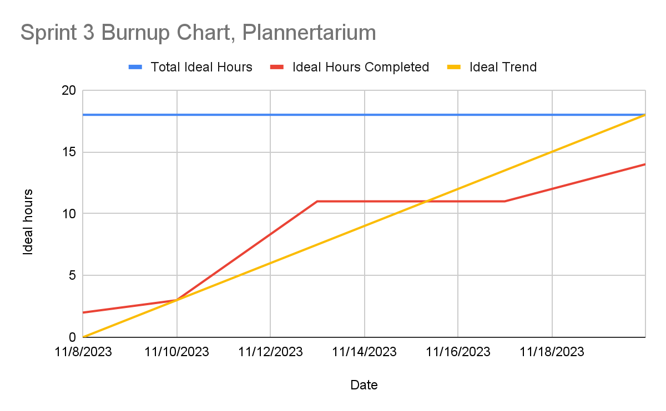

We started off ahead of the ideal trend and kept it up until around midway through the sprint, where we fell behind. The strong start was due to the tasks that were completed in the first half of the sprint, which were mostly backend tasks. Our progress slowed down in the second half because the remaining tasks were all frontend, which proved to be much harder to fully complete according to our definition of done. All of these tasks were started and many of them were almost completed, but because they didn’t meet our definition of done we did not mark them off on our scrum board or add their hours to the burnup chart. Additionally, we estimated that many of our tasks would take 0 ideal hours to complete, but even though they ended up consuming much more time than we expected, it makes no difference on the burnup chart.

# Completed Scrum Board

